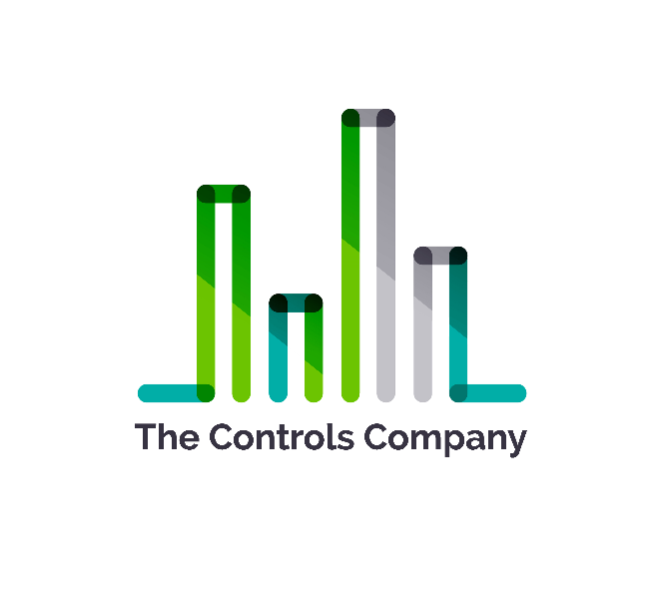
2615 Tambridge Circle
Pensacola, Fl 32503

To whom it may concern:

OSHA forms do not currently apply to The Controls Company. We are a startup founded in 2020 with fewer than 10 employees.

Sincerely,

David Harrison
David@thecontrolscompany.com
850-380-6318

5432 Any Street West, Townsville, State 54321
555.543.5432 ph 555.543.5433 fax
www.yourwebsitehere.com

